How to open sql?
Just write sqlplus in the command promt!

How to connect to a database?
Open sql
Connect username/password;

How to see existing users?
First u have to connect to the database.
Select username from DBA_USERS; /
Select username from DBA_USERS order by Username; /
select username,created from dba_users order by created; /
select username,created from dba_users order by created desc;

how to grant session privilege?
GRANT CREATE SESSION TO username (this doesn’t include desc dba_users;)
or
GRANT CREATE SESSION TO username WITH ADMIN OPTION.

GRANT CONNECT, RESOURCE, DBA TO books_admin;

How to alter the system password in case of u forgotten it?
SQL>conn / as sysdba
SQL>alter user Username identified by PASSWORD;
(http://ccm.net/faq/4399-oracle-recover-lost-passwords)

How to create an user in oracle?
CREATE USER username IDENTIFIED BY password

How to change password?
ALTER USER username IDENTIFIED BY password;

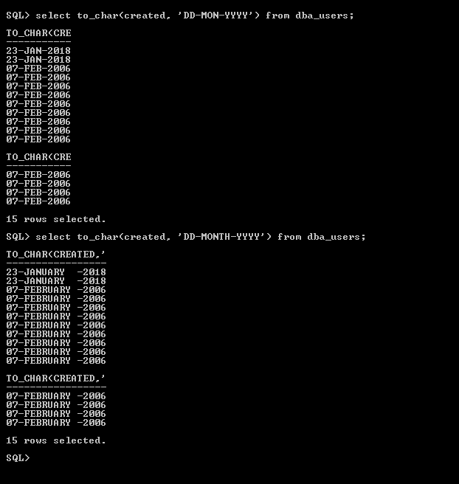
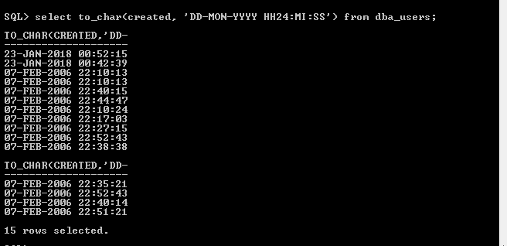

If u want to connect sql from cmd, just type sqlplus !

Create table dept (
deptID number,
deptName varchar2(20)
);

Desc dept;
https://www.w3resource.com/sql/creating-and-maintaining-tables/sql-create-table.php

#adding primary key to the already created table:

How to show all the tables that are under sabbir?
Desc dba_tables;

How to disconnect sabbir?
Disc

CONSTRAINT constraint_name PRIMARY KEY (column1, column2, ... column_n)

CREATE TABLE STD(
SID NUMBER,
SNAME VARCHAR(20),
CONSTRAINTS PK_STD PRIMARY KEY (SID)
);

